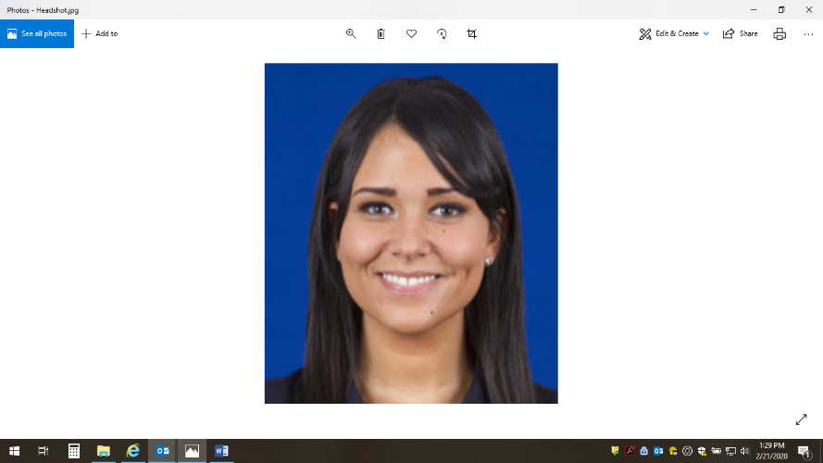**Giuseppe Colletti**

TBD

Specialist, Employee Experience

Hometown: Queens, NY

Favorite sport: Tennis

Favorite Pastime: Trading the stock market

Three Celebrity Dinner Guests: Elon Musk, Warren Buffet, Barack Obama

Favorite Quote: “He who has a why to live can bear almost any how” - Nietzsche

Professional Book Recommendation: Outliers by Malcom Gladwell

Giuseppe (who usually goes by Joe) is part of the Employee Experience team’s Insights group. He received his master’s degree in Industrial/Organizational psychology and has built a career around providing analysis and actionable insights. He previously worked in market research and provided insights to industry leading companies and to their customers. He now uses his skills to provide Northwell Health with data driven solutions to enhance the employee experience as well as drive strategy. These strategies involve many different data sources, including the annual Employee Engagement survey; which he has helped execute since 2019.

Joe enjoys reading, and tracking the stock market. He’s an avid trader/investor and enjoys looking at trends in his spare time. He also enjoys the gym and the tennis court where he can work on his serve and footwork.